WEATHER POLICY 2013
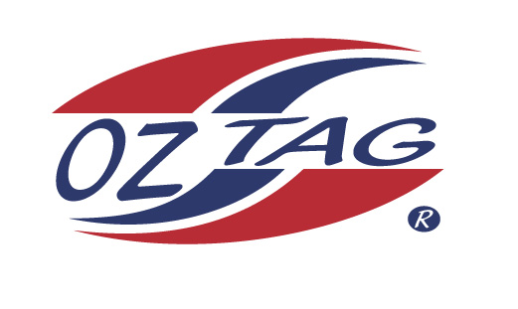
In the past we have experienced torrential rain before and during the tournament however it has not stopped the tournament from going ahead.
A wet weather plan has been formulated to move all games onto the main arena if by chance the outside fields are closed.
If for any reason the tournament is cancelled prior to the day of the tournament a notice will be placed on the website www.oztag.com.au .
All coaches/managers/associations should check the website on the evening prior to the tournament. It will then be their responsibility to inform players/teams of the cancellation. Entry fee will be fully refunded.
If the weather causes the tournament to be cancelled on the day of the tournament the decision will be made by 12pm. It will be posted on the website and a message left on the wet weather number.
If you do not have access to the website, please call the Oztag wet weather number 0427 239 460 after this time
Should the tournament commence and need to be stopped due to inclement weather the siren will sound three long blasts. Play will halt and all persons should seek cover. A decision will be made by the tournament director when play will resume or if the days play is to be abandoned.
Exceptionally hot and humid weather will also be considered. In the event of extremely hot uncomfortable weather the tournament director will consult with the Referee’s Director and determine whether play should continue or be abandoned.
The tournament director’s decision will be final taking into consideration ‘his duty of care’ and the safety of everybody involved in the tournament.
If the tournament is cancelled or abandoned, the AOSA will make a decision whether or not the tournament will be re-scheduled on another date.
If the tournament is abandoned after it has commenced the AOSA will consider a partial refund of the entry fee depending on when the tournament is abandoned.
If play is abandoned during a grand final, the team leading at the time will be declared the champions. If the grand final hasn’t been played then the team finishing highest in the regular competition will be declared champions. Should points be the same, for and against will declare the champion.

